**Exercise 1**

*Start up an instance on Amazon EC2 and get Apache web server running*

**Prior Knowledge**

Unix Command Line Shell

**Learning Objectives**

Understand about EC2 instances

Start an instance using the web interface

Configure the AWS command line

Manage instances from a command line

Understand Security Groups

**Software Requirements**

(see separate document for installation of these)

* AWS CLI

**Part A: Starting an Instance from the Web Console.**

1. You have been provided with an Ubuntu VM. Start that up.
2. The course is also providing time and resources on the Amazon AWS/EC2 cloud for the duration of the course. You may prefer to use your own Amazon AWS account instead.
   1. If you wish to do so, there are instructions here: <http://docs.aws.amazon.com/AWSEC2/latest/UserGuide/get-set-up-for-amazon-ec2.html>   
        
      New users to Amazon get 750 hours of free usage for small (t2.micro) instances.
   2. Start again at step number 6
3. If you wish to use the provided account, continue here.
4. Open up a browser window and navigate to   
   [**https://ox-clo.signin.aws.amazon.com/console**](https://ox-clo.signin.aws.amazon.com/console) 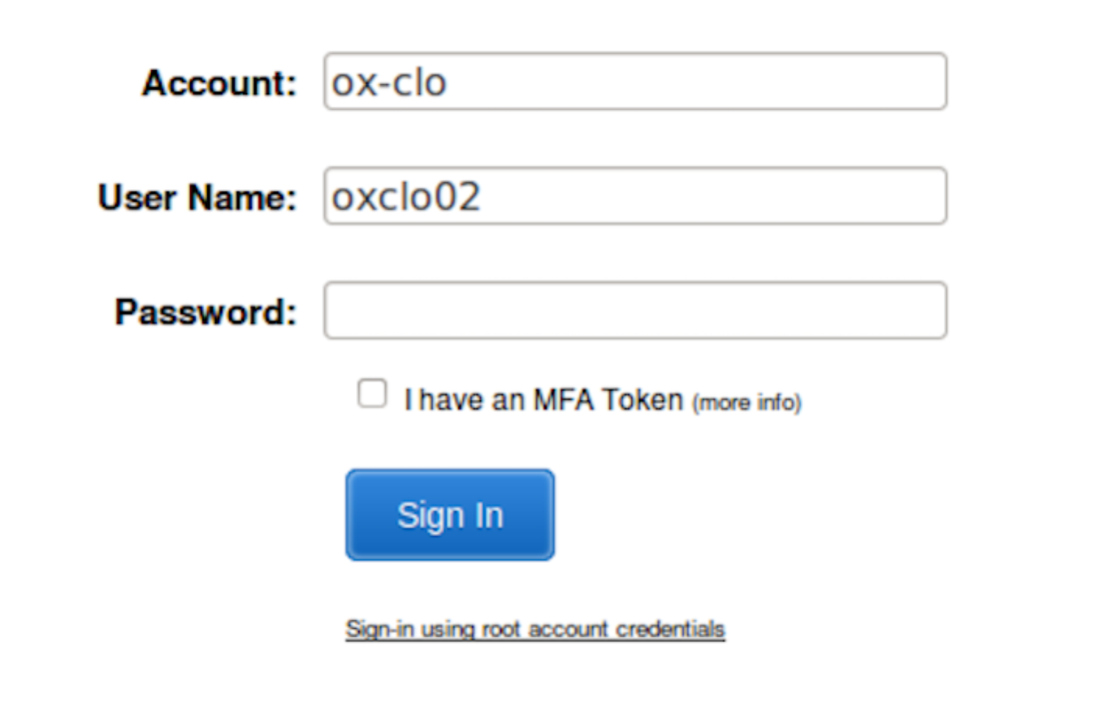
5. Use the userid and password that you have been given. You will need to create a new password:  
     
   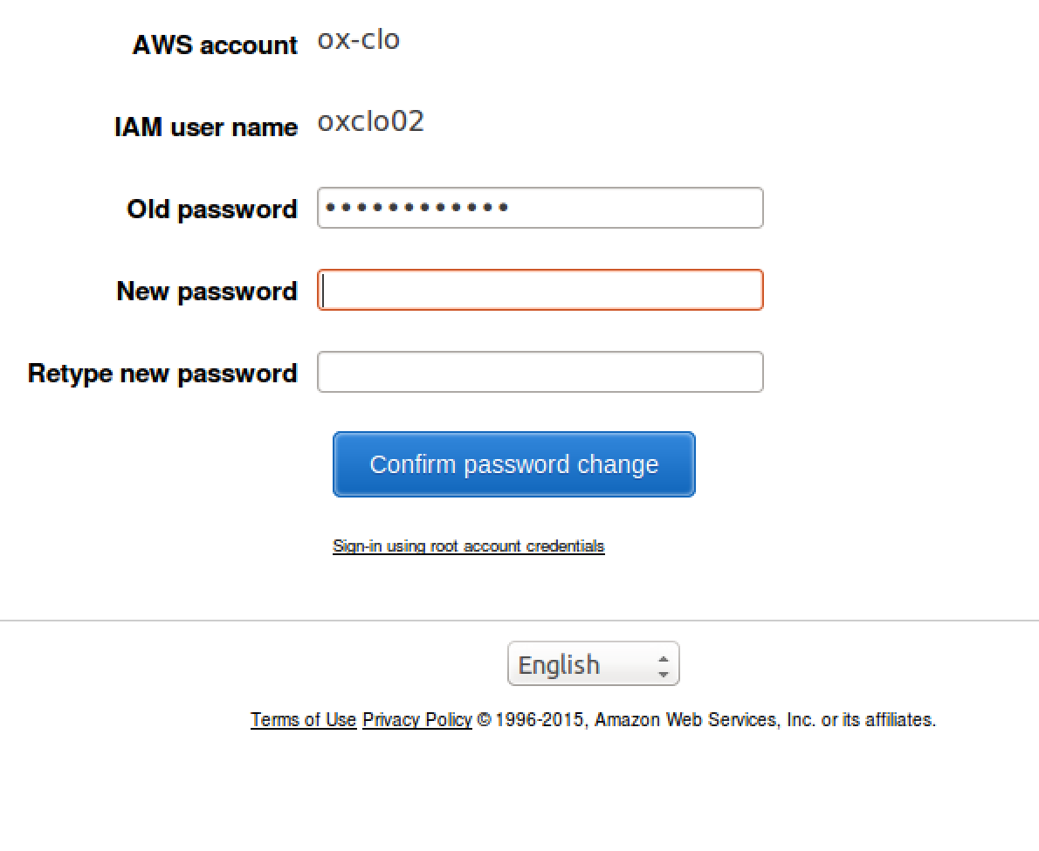
6. You should see a screen like this:  
   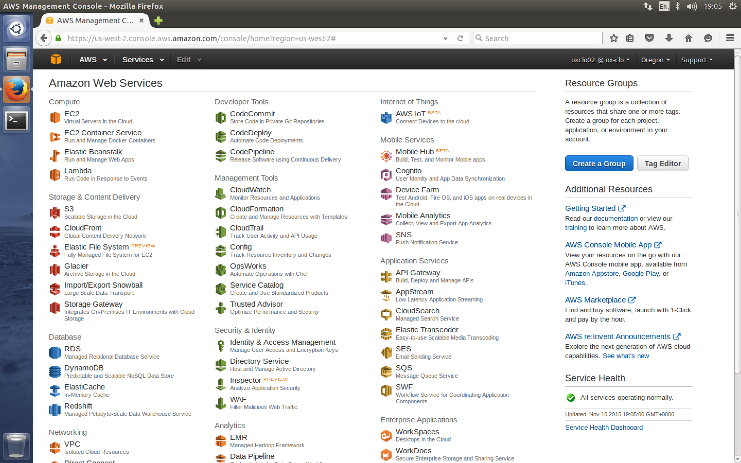
7. In the top right corner click on Oregon and change to one of EU (Ireland), EU (Frankfurt) or US East (N. Virginia).
8. Now click on the top left EC2  
   
9. You will be working in a shared environment with other students on the course (unless you have chosen to use your own Amazon account). As a result, we will need to be very careful not to interfere with other students’ instances, volumes, etc. Therefore please be careful to tag and name your resources clearly so that you can identify them. (Instructions on how to do that will follow!). As a result, the screen below will differ depending on who has done different parts of this exercise.  
     
   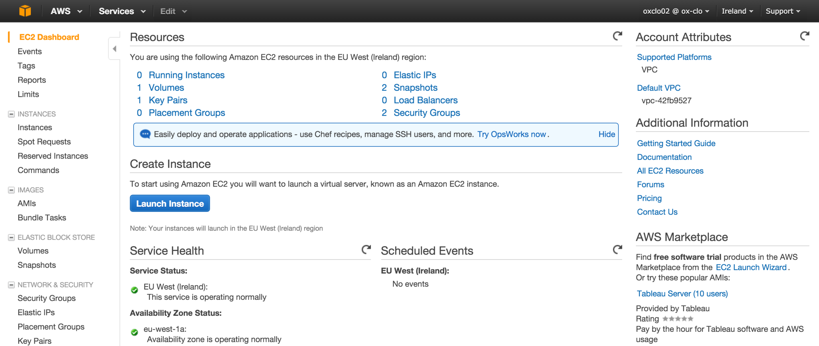
10. Click on the blue button: Launch Instance
11. Choose “**Ubuntu Server 14.04 LTS (HVM), SSD Volume Type** - ami-47a23a30”
12. Choose the instance type **t2.micro**.
13. Click **Next: Configure Instance Details**
14. Click **Next: Add Storage**
15. Click **Next: Tag Instance**
16. In the Tag Instance screen, give your instance a name that is the same as your userid:   
    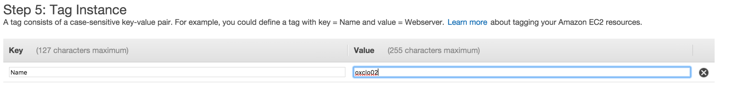
17. Now click: **Next: Configure Security Group**
18. Change the name of the security group to your userid.  
      
    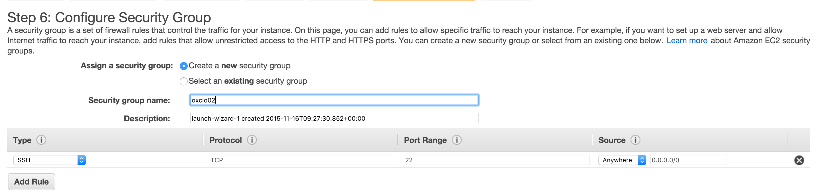

*Hint: There is a security warning about the security rule. The default rule allows Secure Shell (SSH) access from any IP address. If you know your company or personal internet connection comes from a specific IP address you can improve security by restricting to that.*

*Note this is NOT the IP address you get by looking at the local machine’s configuration, but the publicly visible IP address that the Amazon cloud sees from you. You can see what your IP is by typing “what’s my IP” into Google.*

*However, I am not sure if the Oxford network sends messages from different IPs or the same and therefore we will leave this as-is despite the warning.*

1. Click **Review and Launch**You should see something very like this:  
   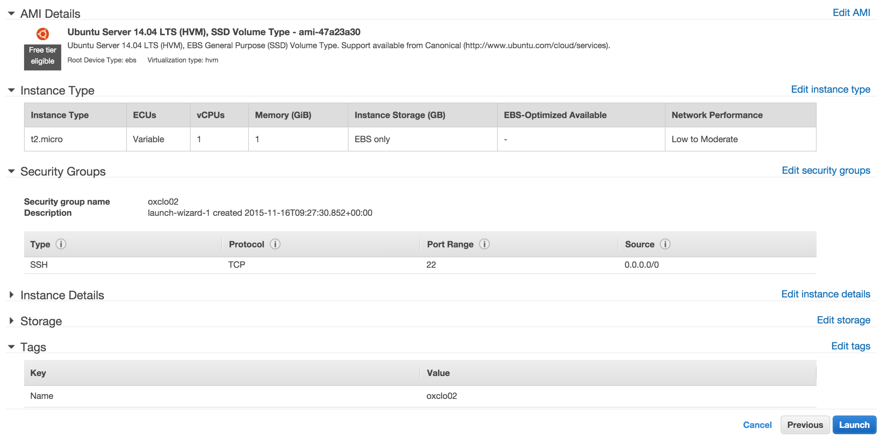
2. Click **Launch**
3. You will be prompted with a new window to decide on the correct key pair to secure this instance with. Since this is the first time you are using EC2, you need to create a key pair. Change the dropdown box to **Create a new key pair.**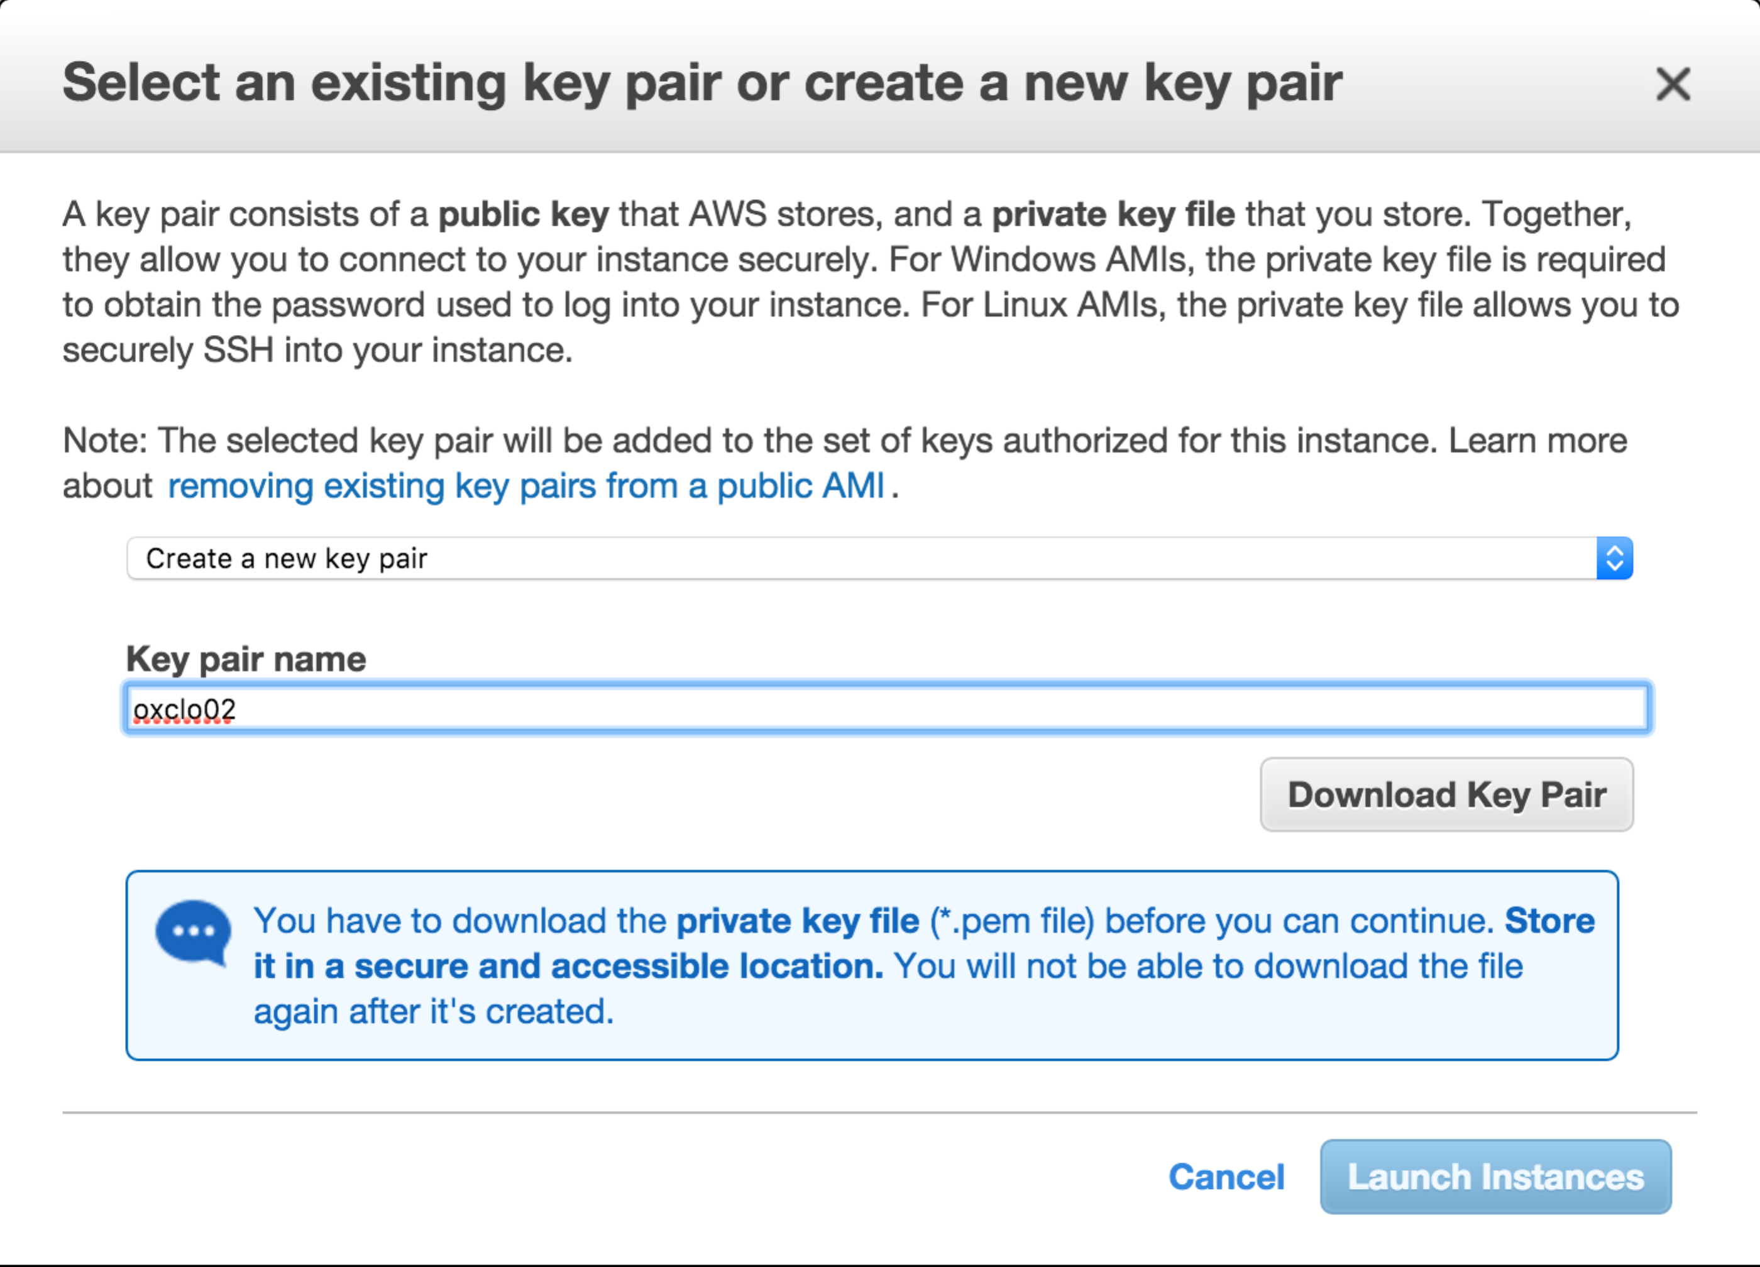
4. Change the name of the key pair to your userid.
5. Click **Download Key Pair**. This will save a file to your ~/Downloads directory.
6. Click **Launch**You should see something like:  
   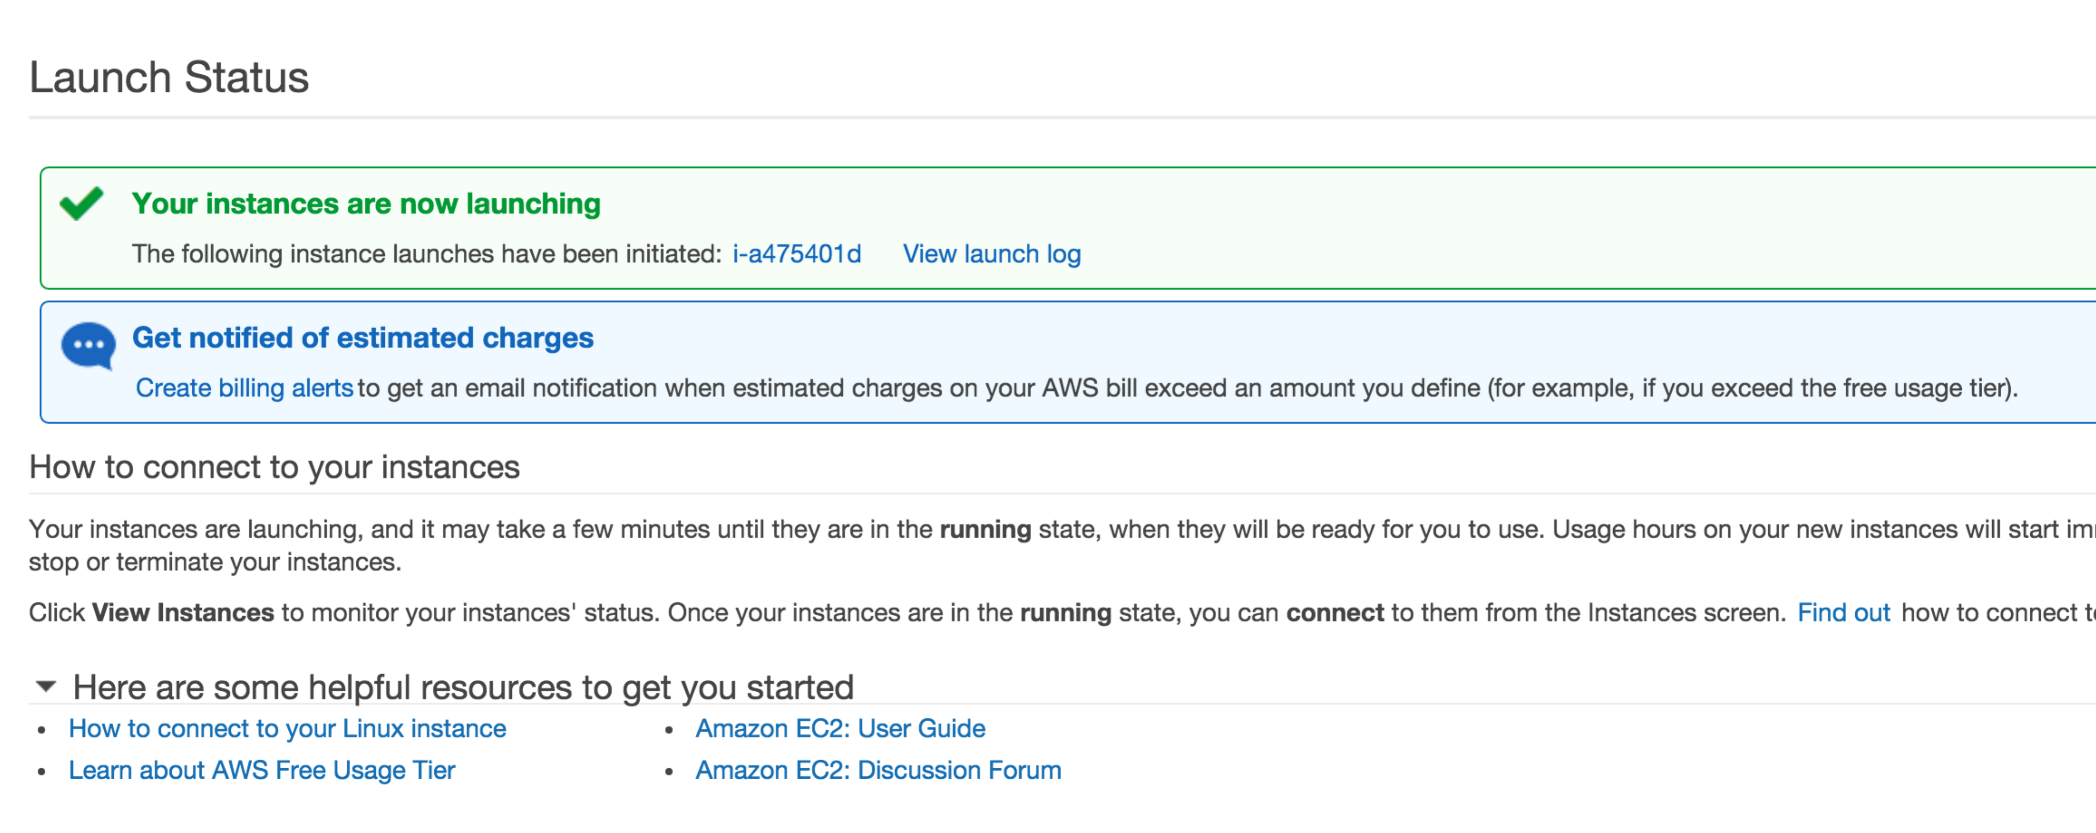
7. Click on the blue instance ID link (e.g. **i-a475401d**in the screenshot above)  
   You will see a dashboard like:  
   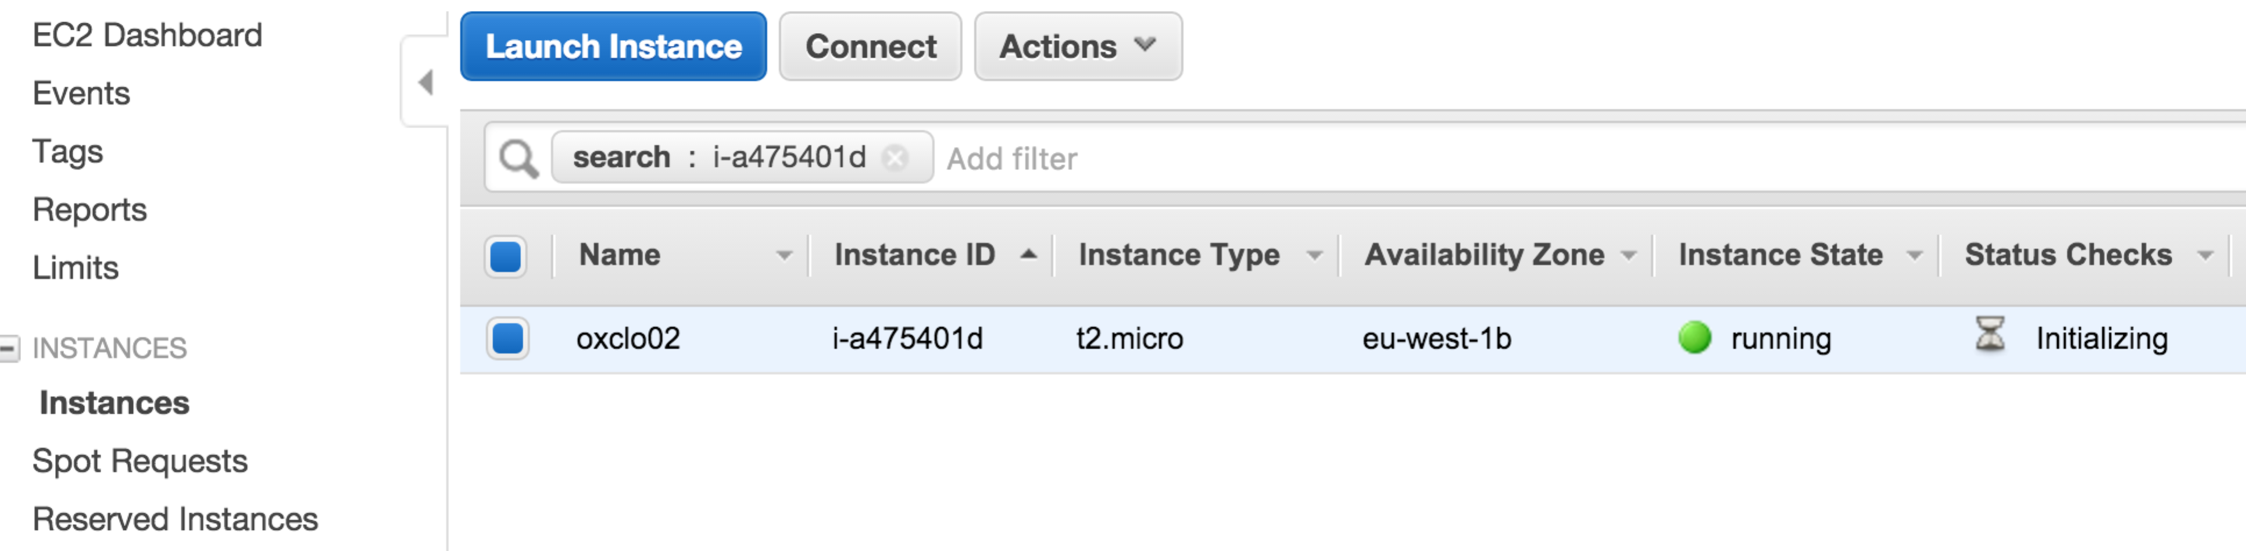
8. Make sure you are running the Ubuntu VM, and start a fresh terminal window (Ctrl-Alt-T, or find Terminal graphically)
9. Make a directory to store your private key:  
   mkdir keys
10. Copy your private key to the new directory:  
    cp ~/Downloads/oxclo**\*.**pem ~/keys/
11. Before you can use the key you need to change the permissions on it. Type:  
    chmod 400 ~/keys/oxclo*.pem
12. Check to see if the status checks on your instance are now complete. Refresh the browser window:  
    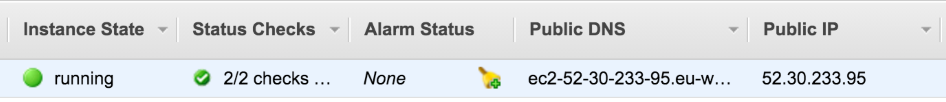
13. Copy the Public IP Address from the browser window (e.g. 52.30.233.95 in my case)
14. Try to SSH into the machine. Replace your key file name and the IP address below!  
      
    ssh –i ~/keys/oxclo**nn**.pem [ubuntu@**ww.xx.yy.zz**](mailto:ubuntu@ww.xx.yy.zz)
15. As this is the first time you are accessing this host, the key on the server side is not known. You should see something like:  
      
    The authenticity of host '52.30.233.95 (52.30.233.95)' can't be established.  
    ECDSA key fingerprint is SHA256:7GhOakN9Pj3vWAegV0uYhPVI9qqVEe9RlNM0wcutO1E.   
    Are you sure you want to continue connecting (yes/no)?

Type **yes** and hit Enter.

You will see something like:

Welcome to Ubuntu 14.04.2 LTS (GNU/Linux 3.13.0-48-generic x86_64)

* Documentation: https://help.ubuntu.com/

System information as of Mon Nov 16 09:50:28 UTC 2015

System load: 0.32 Memory usage: 5% Processes: 82

Usage of /: 9.8% of 7.74GB Swap usage: 0% Users logged in: 0

Graph this data and manage this system at:

https://landscape.canonical.com/

Get cloud support with Ubuntu Advantage Cloud Guest:

http://www.ubuntu.com/business/services/cloud

0 packages can be updated.

0 updates are security updates.

The programs included with the Ubuntu system are free software;

the exact distribution terms for each program are described in the

individual files in /usr/share/doc/*/copyright.

Ubuntu comes with ABSOLUTELY NO WARRANTY, to the extent permitted by

applicable law.

ubuntu@ip-172-31-23-34:~$

1. Type cd and then enter, to switch to the home directory of user *oxclo.*
2. Now let’s format the HDFS filesystem:  
   hadoop namenode -format
3. You should see a lot of output ending something similar to this:

15/10/22 09:15:20 INFO namenode.FSNamesystem: Retry cache on namenode is enabled

15/10/22 09:15:20 INFO namenode.FSNamesystem: Retry cache will use 0.03 of total heap and retry cache entry expiry time is 600000 millis

15/10/22 09:15:20 INFO util.GSet: Computing capacity for map NameNodeRetryCache

15/10/22 09:15:20 INFO util.GSet: VM type = 64-bit

15/10/22 09:15:20 INFO util.GSet: 0.029999999329447746% max memory 889 MB = 273.1 KB

15/10/22 09:15:20 INFO util.GSet: capacity = 2^15 = 32768 entries

15/10/22 09:15:20 INFO namenode.FSImage: Allocated new BlockPoolId: BP-420615264-127.0.1.1-1445501720083

15/10/22 09:15:20 INFO common.Storage: Storage directory /usr/local/hadoop_store/hdfs/namenode has been successfully formatted.

15/10/22 09:15:20 INFO namenode.NNStorageRetentionManager: Going to retain 1 images with txid >= 0

15/10/22 09:15:20 INFO util.ExitUtil: Exiting with status 0

15/10/22 09:15:20 INFO namenode.NameNode: SHUTDOWN_MSG:

/************************************************************

SHUTDOWN_MSG: Shutting down NameNode at oxclo/127.0.1.1

************************************************************/

1. Now let’s start the Hadoop filesystem. Type:   
     
   start-dfs.sh  
     
   You should see output like:

15/10/22 09:18:52 WARN util.NativeCodeLoader: Unable to load native-hadoop library for your platform... using builtin-java classes where applicable

Starting namenodes on [localhost]

localhost: starting namenode, logging to /usr/local/hadoop/logs/hadoop-hduser-namenode-oxclo.out

localhost: starting datanode, logging to /usr/local/hadoop/logs/hadoop-hduser-datanode-oxclo.out

Starting secondary namenodes [0.0.0.0]

0.0.0.0: starting secondarynamenode, logging to /usr/local/hadoop/logs/hadoop-hduser-secondarynamenode-oxclo.out

15/10/22 09:19:08 WARN util.NativeCodeLoader: Unable to load native-hadoop library for your platform... using builtin-java classes where applicable

1. Now let’s make a directory:  
     
   hadoop fs -mkdir -p /user/oxclo/winddata
2. And check it worked:

hadoop fs -ls -R /

You should see:

drwxr-xr-x - oxclo supergroup 0 2015-11-03 10:33 /user

drwxr-xr-x - oxclo supergroup 0 2015-11-03 10:33 /user/oxclo

drwxr-xr-x - oxclo supergroup 0 2015-11-03 10:33 /user/oxclo/winddata

1. Now let’s copy some datafiles from the local filesystem into the HDFS:  
     
   hadoop fs -put ~/datafiles/wind/2015/* /user/oxclo/winddata
2. If you repeat the command to list the files on the hadoop filesystem:

hadoop fs -ls -R /

you should see the new files in place:  
  
15/11/03 10:34:57 WARN util.NativeCodeLoader: Unable to load native-hadoop library for your platform... using builtin-java classes where applicable

drwxr-xr-x - oxclo supergroup 0 2015-11-03 10:33 /user

drwxr-xr-x - oxclo supergroup 0 2015-11-03 10:33 /user/oxclo

drwxr-xr-x - oxclo supergroup 0 2015-11-03 10:33 /user/oxclo/winddata

-rw-r--r-- 1 oxclo supergroup 2716705 2015-11-03 10:33 /user/oxclo/winddata/SF04.csv

-rw-r--r-- 1 oxclo supergroup 7896961 2015-11-03 10:33 /user/oxclo/winddata/SF15.csv

-rw-r--r-- 1 oxclo supergroup 7250586 2015-11-03 10:33 /user/oxclo/winddata/SF17.csv

-rw-r--r-- 1 oxclo supergroup 5538010 2015-11-03 10:33 /user/oxclo/winddata/SF18.csv

-rw-r--r-- 1 oxclo supergroup 5818496 2015-11-03 10:33 /user/oxclo/winddata/SF36.csv

-rw-r--r-- 1 oxclo supergroup 4952077 2015-11-03 10:33 /user/oxclo/winddata/SF37.csv

1. Congratulations you have successfully completed part A.

**Part B. Creating a mapper and reducer, and running map reduce**

1. We have a lot of environmental and wind data from San Francisco, which we can analyse for various information.
2. First, let’s look at the format of the input data.  
   Type   
   hadoop fs -cat /usr/oxclo/winddata/SF37.csv | head  
   You should see:

15/10/22 10:33:52 WARN util.NativeCodeLoader: Unable to load native-hadoop library for your platform... using builtin-java classes where applicable

Station_ID,Station_Name,Location_Label,Interval_Minutes,Interval_End_Time,Wind_Velocity_Mtr_Sec,Wind_Direction_Variance_Deg,Wind_Direction_Deg,Ambient_Temperature_Deg_C,Global_Horizontal_Irradiance

SF37,"Chinatown Medical Center","Chinatown Medical Center",5,2015-01-5? 06:15,3.59,0,263.1,8.61,0

SF37,"Chinatown Medical Center","Chinatown Medical Center",5,2015-01-5? 06:20,3.342,0,268.3,8.58,0

SF37,"Chinatown Medical Center","Chinatown Medical Center",5,2015-01-5? 06:25,3.175,0,271.3,8.45,0

SF37,"Chinatown Medical Center","Chinatown Medical Center",5,2015-01-5? 06:30,2.586,0,279.7,8.45,0

SF37,"Chinatown Medical Center","Chinatown Medical Center",5,2015-01-5? 06:35,3.137,0,273.8,8.44,0

SF37,"Chinatown Medical Center","Chinatown Medical Center",5,2015-01-5? 06:40,2.781,0,277.9,8.54,0

SF37,"Chinatown Medical Center","Chinatown Medical Center",5,2015-01-5? 06:45,3.177,0,269.9,8.66,0

SF37,"Chinatown Medical Center","Chinatown Medical Center",5,2015-01-5? 06:50,2.802,0,277.5,8.72,0

SF37,"Chinatown Medical Center","Chinatown Medical Center",5,2015-01-5? 06:55,3.135,0,273.1,8.65,0

cat: Unable to write to output stream.

1. There is a header line and then a set of data, all in comma separated value (CSV) format.
2. Let’s start by calculating maximum wind velocity for each district over the given period (the current year).
3. To do this, we can simply extract the Station_ID and the Wind_Velocity_Mtr_sec from each line using the mapper, and then we can summarize this information in the Reducer.
4. There is a skeleton mapper written for you in the directory:  
   ~/wind-analysis/mapper.py
5. Change to that directory:  
   cd ~/wind-analysis
6. Edit this mapper to output the right key/value pairs.
   1. You can use any Unix text editor. If you know how, then nano is a good terminal based editor. Otherwise I would suggest using gedit, which is called “Text Editor” in the Ubuntu windowing system.
   2. The usual way of passing the key/value pairs from the mapper to the reducer is to use Tab delimited lines. A quick and easy way of printing those out in Python is to create an array of results and then use the join function to link them up with tabs:

result = [ k, v ]  
print (‘\t’.join(result))

* 1. Don’t forget that Python is tab/space sensitive!

1. Before we run this using Hadoop, we can simply test our script using the command-line.   
   1. We first need to make the mapper.py executable:  
      chmod +x ./mapper.py
   2. We will use the local copy of one of the files
   3. Type:   
      cat ~/datafiles/wind/2015/SF37.csv | ./mapper.py
   4. You should see data lines like this printed:  
       SF37 1.229
2. Now we need to create a reducer:  
   1. Once again start with the skeleton that is provided in reducer.py
   2. Edit this file
   3. I recommend using a python dictionary (<https://docs.python.org/2/tutorial/datastructures.html#dictionaries>) to collect the maximum value by station id, but you could also rely on the fact that Hadoop will sort the data by key before passing it to the reducer. (In other words, if the station id is different from the last station id, then that station id is no longer going to appear).
   4. Hint: you need to convert the number to a string before printing it with the join function, you can do this by using str(max)
3. Check that your code works locally before we try it with Hadoop  
   cat ~/datafiles/wind/2015/SF37.csv | ./mapper.py | ./reducer.py
4. You should see:   
   SF37 2.325  
   printed out.
5. Now we are ready to run this as a map-reduce job using Hadoop. Firstly, this will run different files on (potentially) different systems and processes. Secondly, it will access the data from HDFS instead of the local file system.
6. Before we can run the map-reduce job, we need to start up YARN, the job scheduler.
   1. Type:

start-yarn.sh

* 1. You should see:  
       
     starting yarn daemons

starting resourcemanager, logging to /usr/local/hadoop/logs/yarn-hduser-resourcemanager-oxclo.out

localhost: starting nodemanager, logging to /usr/local/hadoop/logs/yarn-hduser-nodemanager-oxclo.out

1. Now we can initiate the job. To run the python job, we utilize a generic capability of Hadoop to run code that uses standard input/output. Of course we’ve written those Python programs to do exactly that. This capability is called Hadoop Streaming  
   1. Type  
        
      yarn jar /usr/local/hadoop/share/hadoop/tools/lib/hadoop-streaming-2.7.1.jar -input /user/oxclo/winddata/ -output /user/oxclo/output -mapper ./mapper.py -reducer ./reducer.py
   2. You should see a **lot** of log output, ending something similar to:

15/10/23 14:35:38 INFO mapred.Task: Task attempt_local1643623661_0001_r_000000_0 is allowed to commit now

15/10/23 14:35:38 INFO output.FileOutputCommitter: Saved output of task 'attempt_local1643623661_0001_r_000000_0' to hdfs://localhost:54310/user/oxclo/output/_temporary/0/task_local1643623661_0001_r_000000

15/10/23 14:35:38 INFO mapred.LocalJobRunner: Records R/W=235183/1 > reduce

15/10/23 14:35:38 INFO mapred.Task: Task 'attempt_local1643623661_0001_r_000000_0' done.

15/10/23 14:35:38 INFO mapred.LocalJobRunner: Finishing task: attempt_local1643623661_0001_r_000000_0

15/10/23 14:35:38 INFO mapred.LocßalJobRunner: reduce task executor complete.

15/10/23 14:35:39 INFO mapreduce.Job: map 100% reduce 100%

15/10/23 14:35:39 INFO mapreduce.Job: Job job_local1643623661_0001 completed successfully

15/10/23 14:35:39 INFO mapreduce.Job: Counters: 35

File System Counters

FILE: Number of bytes read=6670124

FILE: Number of bytes written=17106042

FILE: Number of read operations=0

FILE: Number of large read operations=0

FILE: Number of write operations=0

HDFS: Number of bytes read=170316404

HDFS: Number of bytes written=44

HDFS: Number of read operations=78

HDFS: Number of large read operations=0

HDFS: Number of write operations=9

Map-Reduce Framework

Map input records=392695

Map output records=235183

Map output bytes=2485256

Map output materialized bytes=2955658

Input split bytes=600

Combine input records=0

Combine output records=0

Reduce input groups=5

Reduce shuffle bytes=2955658

Reduce input records=235183

Reduce output records=4

Spilled Records=470366

Shuffled Maps =6

Failed Shuffles=0

Merged Map outputs=6

GC time elapsed (ms)=300

Total committed heap usage (bytes)=3470262272

Shuffle Errors

BAD_ID=0

CONNECTION=0

IO_ERROR=0

WRONG_LENGTH=0

WRONG_MAP=0

WRONG_REDUCE=0

File Input Format Counters

Bytes Read=34172835

File Output Format Counters

Bytes Written=44

15/10/23 14:35:39 INFO streaming.StreamJob: Output directory: /user/oxclo/output

* 1. Now you can check if there is any output:  
       
     hadoop fs –cat /user/oxclo/output/part-00000
  2. You should see:  
     15/10/23 14:38:44 WARN util.NativeCodeLoader: Unable to load native-hadoop library for your platform... using builtin-java classes where applicable

SF18 10.57

SF36 11.05

SF37 7.079

SF04 34.12

* 1. If you do not see the same output, then check your code and re-run. If you re-run you will need to specify a new output directory (e.g. output-2).

1. Now modify your code to calculate the average wind velocity at each station.   
     
   Hint 1: copy your reducer.py code to reducer-average.py to start with.  
   Hint 2: you shouldn’t need to change the mapper  
     
   Run your code using hadoop and compare your answers to these:  
     
   SF18 2.22022343917

SF36 2.46417253091

SF37 2.2604035055

SF04 2.30098174812

1. Congratulations! You have completed this exercise.